Introduction
Comfort and well-being in buildings play a crucial role in the overall quality of life for occupants. A comfortable and healthy indoor environment fosters productivity, creativity, and engagement. When occupants are provided with optimal conditions such as good air quality, appropriate temperature and humidity levels, and access to natural light, they experience fewer distractions and can focus better on their tasks. Additionally, prioritizing comfort and well-being in building design creates spaces that promote mental and emotional well-being. This positive atmosphere contributes to a healthier work-life balance, increased job satisfaction, and improved overall quality of life for occupants. Additionally, comfort and well-being in buildings often go hand in hand with energy efficiency and sustainability. Incorporating energy-efficient technologies, utilizing renewable resources, and promoting sustainable practices in building design not only reduce environmental impact but also contribute to long-term cost savings and operational efficiency.
Towards this direction, within PHOENIX project will deliver a service focusing on enhancing the Comfort, Convenience and Wellbeing within the building environment.

Service overview
In this section, a short overview of the service is provided as a short training material for the different features offered to the users of the app.
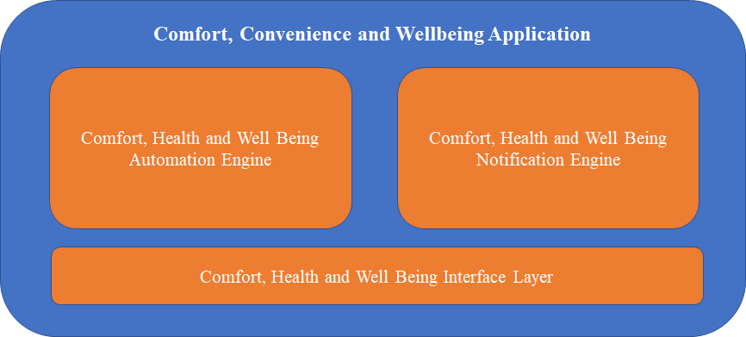
Figure 1 Comfort, Convenience and Wellbeing Engine Overview
As depicted above, the service consists of 3 different interlinked layers, namely
Comfort, Health and Well Being Interface Layer
The role of this module is to act as the wrapper of the service in order to ensure information exchange with the building environment in order to retrieve the relevant data from the building environment
- Access to contextual/environmental information: information about temperature, humidity, luminance and CO2 is available from the different observation points of the project.
- Access to operational settings of controllable devices: information about the operational status of the different smart devices (mainly HVAC systems but also ventilation)

Comfort, Health and Well Being Recommendation Engine
The role of this DSS module is to correlate building contextual conditions along with the comfort profiles and user settings in order to generate the appropriate notifications associated with the indoor conditions in premises. A data driven approach is adopted for the implementation to enable timely, context- aware, quantified, meaningful, accurate and personalized feedback provision in order to maximize comfort and well-being conditions in premises. More specifically, the features of the recommendation approach (via a tailor-made and personalized recommendation engine) include:
- Timely and Context-Aware: triggers and meaningful feedback for timely need-to-act will be offered close to relevant events and necessary actions, taking into account real-time conditions like environmental conditions from sensors (luminance, temperature & humidity)
- Non-intrusive: feedback modality, frequency and context will be configurable to ensure discreteness
- Personalized: feedback will be customized to occupant characteristics and relevant energy behaviours, comfort preferences and contextual requirements. Feedback from the end users is also considered in order to ensure personalization at the different notifications triggered to the users.

The high-level overview of the recommendation engine is presented in the following figure.
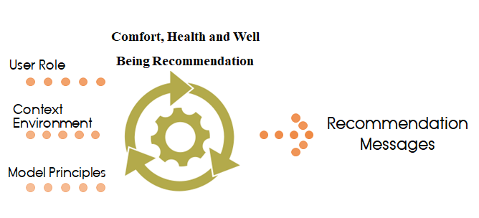
Figure 2 Non-Energy Services Recommendation Engine
More specifically, the enhanced recommendation model takes into account:
- User parameters: user norms /groups defined in the project
- Context conditions: Real time context information values: environmental conditions, device status etc…
- Model parameters incorporated in the analysis:
  - business strategies and priorities: health first, comfort first etc.
  - non-functional aspects are examined as trigger points for the recommendation’s engine, namely: level of participation, level of triggering etc…
It is evident that a multi-dimensional framework is specified for the recommendation engine. The main focus in the project is about the handling of the aforementioned model parameters; towards triggering best fitted recommendations (defined following consultation with the demo partners) to the users based on contextual and operational conditions.
Comfort, Health and Well Being Automation Engine
Complementary to the recommendation Engine, the Comfort, Health and Well Being Automation Engine is also defined as a data driven decision support system to maximize comfort and wellbeing conditions in building premises. Again, contextual conditions from the building environment (environmental conditions, user profiles and device settings) are specified as the input parameters for the DSS systems. By taking into account impact criteria such as the goal objective (comfort vs health), the level of automation (frequency of triggers) and the feedback from the end users (by rating the automation actions performed by the system), the DSS system adapts its operation in order to perform the appropriate control strategies. A high-level overview of the DSS system is presented in the following figure.
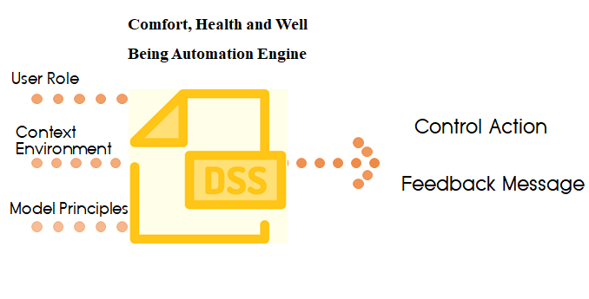
Figure 3 Non-Energy Services Automation Engine
More specifically, the enhanced automation engine takes into account:
- User parameters: user norms /groups defined in the project
- Context conditions: Real time context information values: environmental conditions, device status, device controllability etc…
- Model parameters incorporated in the analysis:
  - business strategies and priorities: health first, comfort first etc.
  - non-functional aspects are examined as trigger points for the recommendation’s engine, namely: level of triggering, level of automation acceptance, etc…

User access and configuration
The users of the app can get access to the different recommendations triggered by the service through a dedicated view of the app. Also, the user is able to provide a rate to the relevant notification in order to further reconfigure the service.
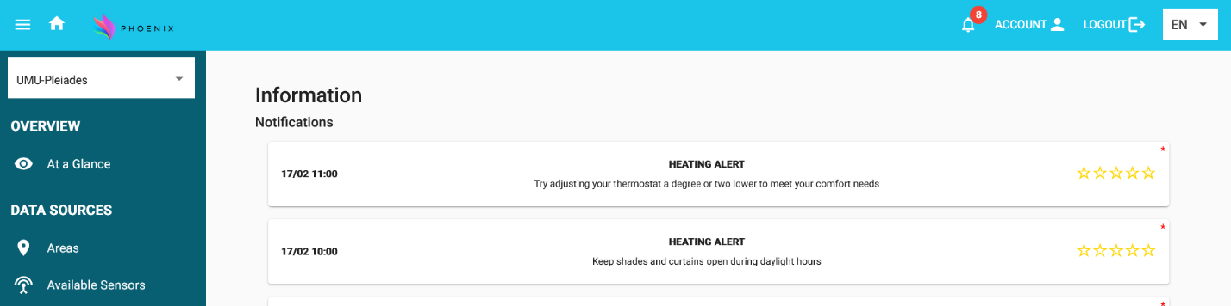
Figure 2 Non-Energy Services related Notifications
On the other hand, information about the comfort status to the different conditions is made available through the dashboard
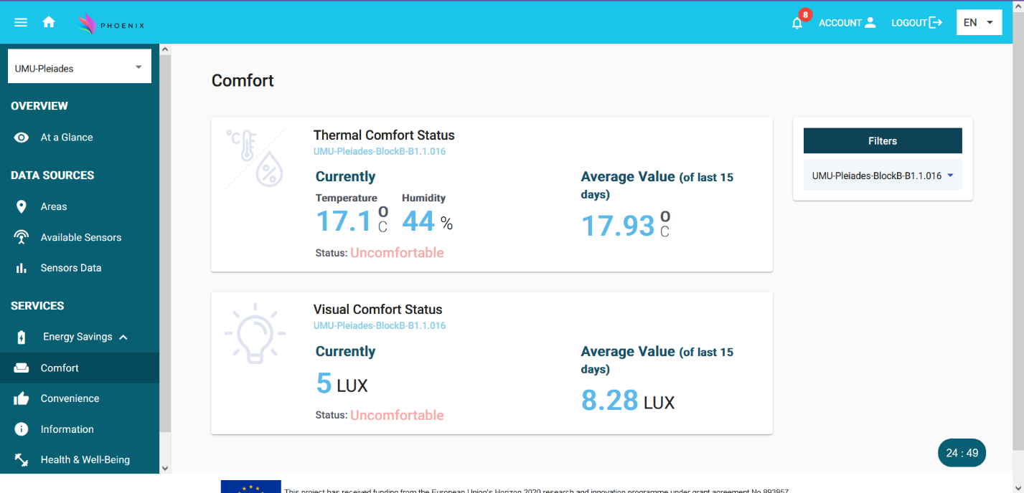
Figure 2 Comfort status in real time environmental conditions
The users may specify the priority mode for the operation of the building (comfort first vs health first). On the other hand, the users are able to rate the different notifications made available through the application as presented above.

Conclusion
The scope of this document is to provide the details for the proposed Comfort, Convenience and Wellbeing services delivered as part of the holistic building management framework. As stated above the role of this service bundle is to first enable identification of poor indoor conditions in buildings that may cause comfort or health issues to the building occupants. Furthermore, the module incorporates smart services that enable either automated control of the building devices to ensure comfort, health and well-being conditions or context based personalized notifications and messages to building occupants related to the comfort and well-being conditions in premises. The business objective of this application is to ensure the establishment of a comfort and health building environment for building occupants.

