Follow us on

The PHOENIX Project in a nutshell
The aspiration of PHOENIX project is to change the role of buildings from unorganized energy consuming structures to active agents orchestrating and optimizing their energy consumption, production and storage. The project’s goal is to increase the energy performance of the currently older building stock, to maximize the occupants’ benefits in terms of convenience, comfort, safety and cost savings, and to facilitate grid operation.
PHOENIX will design a portfolio of Information and Communication technology (ICT) solutions that include:

- Hardware & Software upgrades
- Sensors

- Data analytics
- Services

all of which can be easily integrated in buildings with legacy equipment, and which will benefit both the building users and the energy utilities. To than end, PHOENIX will leverage Artificial Intelligence technologies and edge/cloud computing methods, to provide the highest level of smartness in existing buildings. The improvements brought about by the project translate into personal, intelligent, inclusive and trusted services for building users on the one hand, and into improvements in the management of grid operations and data sharing on the other.

Scope
PHOENIX is well aligned with the framework of the EU, aiming to promote smart building technologies particularly through the establishment of the Smart Readiness Indicator (SRI) for buildings. The SRI provides information on the technological readiness of buildings for interacting with their occupants and the energy grids, and their capabilities for more efficient operation and better performance through ICT technologies in the form of services.

Objectives
The PHOENIX website is now online! Check it out @: www.eu-phoenix.eu
The PHOENIX project focuses on 7 key objectives:
- Allow Adapt-&-Play seamless integration of domestic appliances, legacy equipment and building systems
- Create building knowledge with innovative techniques to upgrade the smartness of existing buildings
- Enable real-time communication with energy stakeholders to optimize the grid operation
- Provide cost-effective services for building end-users to maximize the energy efficiency and overall performance
- Allow security and privacy of building data regarding the revised EPBD and the GDPR law
- Create suitable business models and exploitation strategies to target the broad market of smart buildings
- Develop human-centric approach and training/awareness activities to prepare citizens for smart buildings

The Consortium
The project is carried out by a consortium of 12 partners from 7 EU countries, under the coordination of the University of Murcia (UMU) in Spain.

The Pilots
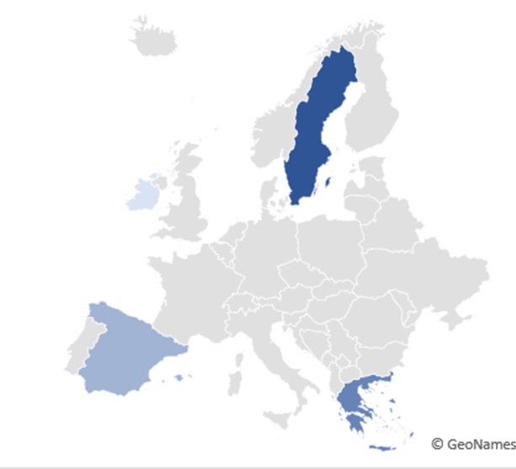
To showcase the real impact of its solution, the PHOENIX consortium validates its concept in 5 pilot sites across Europe, in Greece, Ireland, Spain and Sweden.
Skellefteå Pilot Site (LTU, SKEBIT)
- University of Murcia Pilot
- MIWEnergia Pilot
Ringsend Irishtown Sustainable Energy
Co-operative Pilot
KaMa, Thessaloniki Pilot

PHOENIX News
PHOENIX KICK-OFF MEETING
The PHOENIX project conducted its kick-off meeting on September 29, 2020. Due to the Covid-19 pandemic and following the “stay-at-home” safety guidance, the meeting was decided to be held virtually. The meeting was attended by the 12 partners of the PHOENIX consortium and the European Commission’s delegated Project Officer. During the meeting, the project’s purpose, goal, objectives, highlights and detailed work plan was agreed upon!
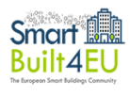
PARTICIPATION IN THE SmartBuilt4EU TASK FORCE 2
The PHOENIX project Coordinator, UMU, participated in the project’s SmartBuilt4EU Task Force 2 discussion. The SmartBuilt4EU project aims to identify challenges and barriers to smart buildings deployment and the associated research and innovation gaps that should be addressed in the years to come. Task Force 2, which was launched in March 2021, focuses on the optimal integration and use of smart solutions to allow an efficient building operation. UMU was one of the 30 participants that joined a fruitful discussion on strengths, benefits and barriers of efficient building operations in terms of interoperability!

THE PHOENIX 1st PLENARY MEETING ON MONTH 6
On May 28, 2021 the PHOENIX 6-month plenary meeting took place online. The meeting, led by the project coordinator UMU, was attended by all project partners and each Work Package leader reported on the progress of their respective activities, and presented clear time plans for the work to be carried out during the coming period. The potential risks were also discussed along with ways to address them and contingency plans!

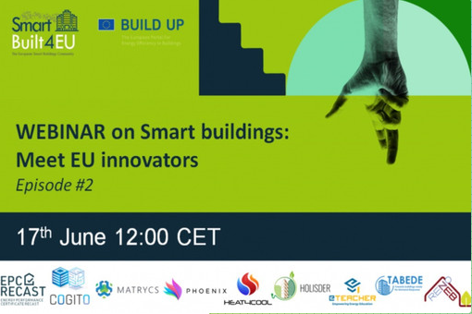
PHOENIX ON THE Smart Building: Meet the EU innovators WEBINAR
PHOENIX participated in the Webinar “Smart Building: Meet the EU Innovators”, which was held on June 17, 2021. During the session participants had the chance to learn about the EU funded projects that are developing and testing solutions that will further improve the smart readiness of buildings, including PHOENIX. Various topics were addressed, including the optimization of energy consumption and (renewable) generation and the provision of flexibility services to the power network!

